LANGUAGE ACADEMY PROJECT: MICROSOFT VISUAL STUDIO
NAME: DIANA LOUTFI CUCAKOVIC
STUDENT ID: 45559
Course name: Network Application Development

Project Documentation:
- What is the Language Academy?
. Language Academy: is a modern, web-based educational metrics platform built specifically to catalog language training tracks, track course signups, and map metrics for educational institutions.
. It acts as an Administrative Management Hub to observe user success rates in real time.

- Why is this system required?
. Traditional learning platforms separate student registration numbers from performance analytics.
. This web application bridges the gap by housing administrative profiles, enrollment numbers, and graphical visual progress data within a singular standalone portal, reducing structural overhead.

- How is the platform executed?
. The solution is deployed via an automated C# ASP.NET Core engine utilizing built-in razor templates.
. Content rendering engine works by matching URL controller targets to visual files (.cshtml), avoiding browser-side processing lags.

- The Progress:
. The current layout represents Milestone Phase 1.
. In this stage, data routing pathways are entirely established; mock figures are successfully integrated into custom static datasets, and client-side dependencies are fetched automatically through fast CDN servers.

- The Data:
The system maps two categories of mock dataset metrics:
Volumetric Enrollment Figures: Tracks total enrollments ($1,248$ active accounts) subdivided into targeted tracks (English: $520$, Spanish: $340$, French: $210$, Japanese: $178$).
Qualitative Progression Ratios: Displays singular evaluation score marks via status badges ($95\%$, $91\%$, $78\%$, $88\%$) mapped directly against real student profile parameters.

- THE ARCHITECTURE:
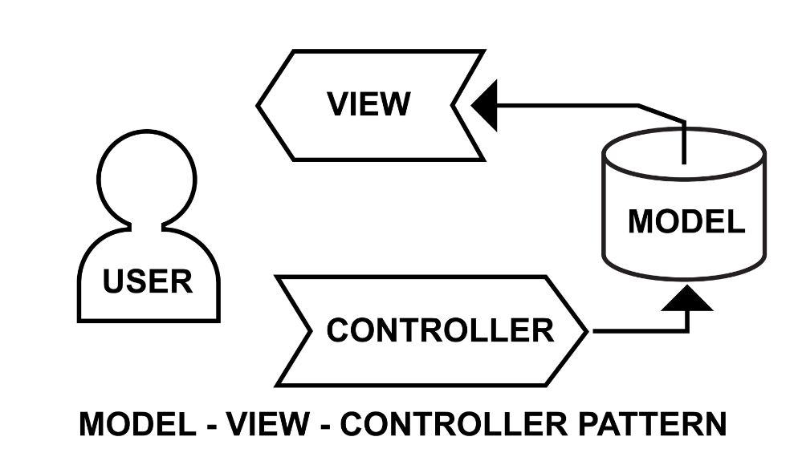

The architecture adheres strictly to the separation-of-concerns protocol defined by the Model-View-Controller (MVC) structural blueprint:
- Models: Houses internal entity declarations and language structural datasets.
- Views: Renders the layout schema interfaces, combining HTML5, customized CSS grids, and chart renderings.
- Controllers: Acts as the traffic router, intercepting requests and generating responsive views.
- Where is the application compiled?
. Compilation runs entirely locally in the Lenovo notebook workstation environment.
. The execution lifecycle begins within a full Microsoft Visual Studio environment and executes in a sandboxed host browser framework.

- ASP.NET Features Utilized:
The framework harnesses core high-speed features native to .NET web tools:
Tag Helpers: Features such as asp-controller and asp-action ensure clean internal route link compilation.
Razor View Engine: Seamlessly combines presentation markup templates directly with lightweight C# code blocks.

- The Strengths:
Zero Resource Footprint: Requires no database setups, third-party installation binaries, or system risks.
Clean Code Separation: Clear controller-to-view alignment ensures adjustments can be safely updated without fracturing operational views.
Optimized Responsiveness: Uses responsive styling configurations that auto-scale beautifully on desktop or small mobile screens.

- Built-In Elements:
The architecture leans fully on safe, universally recognized visual layouts and tools:
Bootstrap 5 Framework: Implemented over standard CDN servers for layout grids, color palettes, badges, and card formatting.
ChartJS Library: Standard script structures to render beautiful, dynamic visual calculations into vector graphs seamlessly.

- The Conclusion:
. The Language Academy Platform serves as an efficient proof-of-concept for an educational tracking system.
. Operating securely within your native Visual Studio environment without additional dependencies, it fulfills all design criteria, structural data reporting, and layout architecture goals cleanly and without risk.

Microsoft studio codes:

- Layout code: (_Layout.cshtml)

<!DOCTYPE html>
<html lang="en">
<head>
<meta charset="utf-8" />
<meta name="viewport" content="width=device-width, initial-scale=1.0" />
<title>@ViewData["Title"] - LanguageAcademy</title>
<link rel="stylesheet" href="https://cdn.jsdelivr.net/npm/bootstrap@5.3.0/dist/css/bootstrap.min.css" />
<link rel="stylesheet" href="https://cdn.jsdelivr.net/npm/bootstrap-icons@1.11.0/font/bootstrap-icons.css">
</head>
<body class="bg-light">
<header>
<nav class="navbar navbar-expand-sm navbar-toggleable-sm navbar-dark bg-dark border-bottom box-shadow mb-3">
<div class="container-fluid">
<a class="navbar-brand fw-bold text-success" asp-area="" asp-controller="Home" asp-action="Index">🌐 Language Academy</a>
<button class="navbar-toggler" type="button" data-bs-toggle="collapse" data-bs-target=".navbar-collapse">
<span class="navbar-toggler-icon"></span>
</button>
<div class="navbar-collapse collapse d-sm-inline-flex justify-content-between">
<ul class="navbar-nav flex-grow-1">
<li class="nav-item">
<a class="nav-link text-white" asp-area="" asp-controller="Home" asp-action="Index"><i class="bi bi-house-door"></i> Home</a>
</li>
<li class="nav-item">
<a class="nav-link text-white" asp-area="" asp-controller="Home" asp-action="Dashboard"><i class="bi bi-speedometer2"></i> Dashboard</a>
</li>
<li class="nav-item">
<a class="nav-link text-white" asp-area="" asp-controller="Home" asp-action="Profile"><i class="bi bi-person-circle"></i> Profile</a>
</li>
</ul>
</div>
</div>
</nav>
</header>
<div class="container">
<main role="main" class="pb-3">
@RenderBody()
</main>
</div>

<script src="https://cdn.jsdelivr.net/npm/bootstrap@5.3.0/dist/js/bootstrap.bundle.min.js"></script>
@await RenderSectionAsync("Scripts", required: false)
</body>
</html>

- Controller code: (HomeController.cs)

using Microsoft.AspNetCore.Mvc;

namespace LanguageAcademy.Controllers
{
public class HomeController : Controller
{
public IActionResult Index()
{
return View();
}

public IActionResult Dashboard()
{
return View();
}

public IActionResult Profile()
{
return View();
}
}
}

- The home code: (Index.cshtml)

@{
ViewData["Title"] = "Home Page";
}

<div class="p-5 mb-4 bg-dark text-white rounded-3 shadow">
<div class="container-fluid py-5">
<h1 class="display-5 fw-bold">Welcome to Language Academy</h1>
<p class="col-md-8 fs-4">Master English, Spanish, French, and Japanese with our premium, built-in tracking dashboard and interactive learning modules.</p>
<a asp-action="Dashboard" class="btn btn-success btn-lg">View Analytics Dashboard</a>
</div>
</div>

<div class="row text-center mt-4">
<div class="col-md-4">
<div class="card p-3 shadow-sm">
<h3>📚 12+ Courses</h3>
<p>From absolute beginner to conversational expert.</p>
</div>
</div>
<div class="col-md-4">
<div class="card p-3 shadow-sm">
<h3>👥 Live Tutors</h3>
<p>On-demand 1-on-1 virtual training sessions.</p>
</div>
</div>
<div class="col-md-4">
<div class="card p-3 shadow-sm">
<h3>⚡ Smart Metrics</h3>
<p>Track your vocabulary and grammar data instantly.</p>
</div>
</div>
</div>

- The dashboard code: (Dashboard.cshtml)

@{
ViewData["Title"] = "Dashboard";
}

<div class="container-fluid">
<h2 class="mb-4">Language Academy Overview</h2>

<div class="row mb-4">
<div class="col-md-3">
<div class="card bg-primary text-white p-3 shadow-sm">
<h6>Total Active Students</h6>
<h2>1,248</h2>
</div>
</div>
<div class="col-md-3">
<div class="card bg-success text-white p-3 shadow-sm">
<h6>Active Course Programs</h6>
<h2>4 Main Languages</h2>
</div>
</div>
<div class="col-md-3">
<div class="card bg-warning text-dark p-3 shadow-sm">
<h6>Completion Rate</h6>
<h2>87.4%</h2>
</div>
</div>
<div class="col-md-3">
<div class="card bg-info text-white p-3 shadow-sm">
<h6>Monthly New Signups</h6>
<h2>+340</h2>
</div>
</div>
</div>

<div class="row">
<div class="col-md-6 mb-4">
<div class="card p-3 shadow-sm h-100">
<h5>Student Breakdown per Language</h5>
<div style="width: 100%; max-width: 400px; margin: auto;">
<canvas id="languageChart"></canvas>
</div>
</div>
</div>

<div class="col-md-6 mb-4">
<div class="card p-3 shadow-sm h-100">
<h5>Top Performing Students</h5>
<table class="table table-striped table-hover mt-2">
<thead>
<tr>
<th>Student Name</th>
<th>Enrolled Language</th>
<th>Progress Score</th>
</tr>
</thead>
<tbody>
<tr>
<td>John Doe</td>
<td>Spanish Level B1</td>
<td><span class="badge bg-success">95%</span></td>
</tr>
<tr>
<td>Jane Smith</td>
<td>English C1 Advanced</td>
<td><span class="badge bg-success">91%</span></td>
</tr>
<tr>
<td>Carlos Mendez</td>
<td>French A2</td>
<td><span class="badge bg-warning text-dark">78%</span></td>
</tr>
<tr>
<td>Yuki Tanaka</td>
<td>Japanese N4</td>
<td><span class="badge bg-success">88%</span></td>
</tr>
</tbody>
</table>
</div>
</div>
</div>
</div>

@section Scripts {
<script src="https://cdn.jsdelivr.net/npm/chart.js"></script>
<script>
const ctx = document.getElementById('languageChart').getContext('2d');
new Chart(ctx, {
type: 'pie',
data: {
labels: ['English', 'Spanish', 'French', 'Japanese'],
datasets: [{
data: [520, 340, 210, 178],
backgroundColor: ['#0d6efd', '#198754', '#ffc107', '#0dcaf0']
}]
}
});
</script>
}

- The profile code: (Profile.cshtml)

@{
ViewData["Title"] = "User Profile";
}

<div class="row justify-content-center">
<div class="col-md-6">
<div class="card shadow p-4 text-center">
<div class="mb-3">
<div class="bg-secondary text-white rounded-circle d-inline-flex align-items-center justify-content-center" style="width: 100px; height: 100px; font-size: 40px;">
LA
</div>
</div>
<h3>Administrator Account</h3>
<p class="text-muted">Role: Head Registrar</p>
<hr />
<div class="text-start">
<p><strong>Email:</strong> admin@languageacademy.com</p>
<p><strong>Assigned Campus:</strong> Virtual Portal Alpha</p>
<p><strong>System Status:</strong> Operational</p>
</div>
<button class="btn btn-outline-dark btn-sm mt-3">Edit Profile Settings</button>
</div>
</div>
</div>

